Campaign Kickoff Email
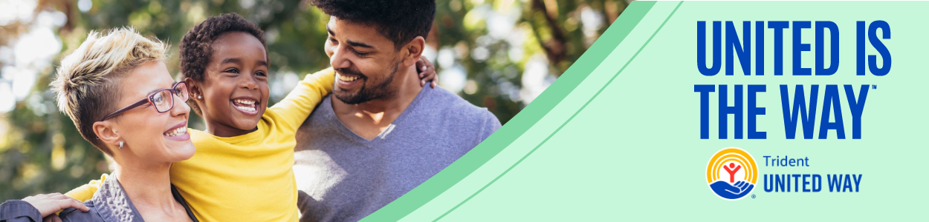
Subject line: Be the Change + Support Hardworking Tri-County Families
Dear [Employee’s Name],
What if one small act could help lift a local family out of poverty?

Join us for [Company Name]’s Workplace Giving Campaign in support of Trident United Way’s Strong Families, Strong Community Initiative, a bold effort to uplift 15,000 families out of poverty by 2035.

Campaign Dates: [Start Date] – [End Date]
Goal: [Fundraising/Participation Goal]
Why Give? Nearly 40% of local households are working hard, but struggling to afford the cost of basics. Your gift helps ALICE® families access one-on-one coaching, better jobs and the support they need to build lasting stability.
Let’s do this, [Company]! Our Trident United Way Campaign Starts Now! See you at the Kickoff Event:
Date: [Event Date]
Location: [Event Location]
Every gift makes a difference. Thank you for being part of the change.
[Your Name]
[Your Title]
[Company Name]

