Mid-Campaign Reminder Email
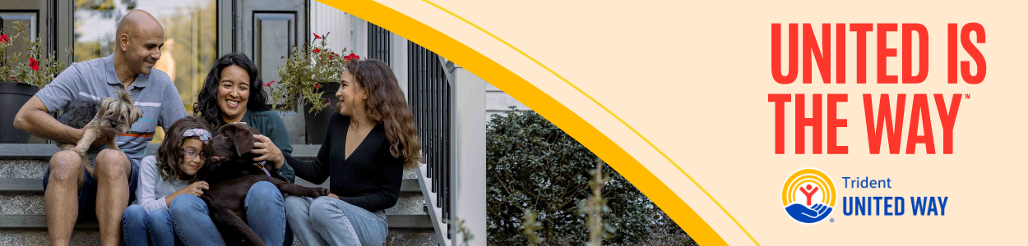
Subject: We’re Halfway There, [COMPANY NAME]! Let’s Finish Strong!
Dear [Employee’s Name],
We’re halfway through our Trident United Way Workplace Giving Campaign and, thanks to our team, real change is happening. But we’re not done yet, and we need your help to cross the finish line.
Progress so far: [Update Goal Progress – % Achieved]
Challenge update: [Mention incentives or competitions]
Each gift from our team creates momentum for ALICE® families, helping them access jobs, overcome obstacles and move toward long-term stability.
Just $[per pay period gift or ] can provide:
- $57 – a CARTA bus pass to help someone get to work
- $75 – a set of scrubs to begin a job in healthcare
If you haven’t had a chance to give yet, now is the time. Let’s come together, finish strong and show what [Company Name] can do for our community!
[Insert Call-to-Action and company specific campaign link - Donate Now / Join the Challenge]
Thank you for empowering Tri-County families to get where they want to go.
[Your Name]
[Your Title]
[Company Name]

