POST-CAMPAIGN/THANK YOU + RESULTS EMAIL CHOOSE ONE HEADER IMAGE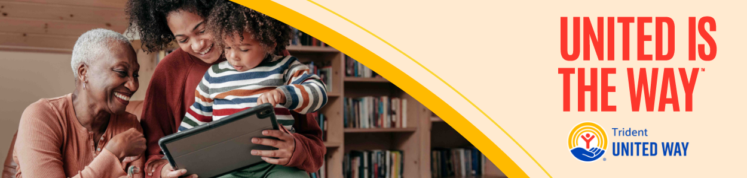

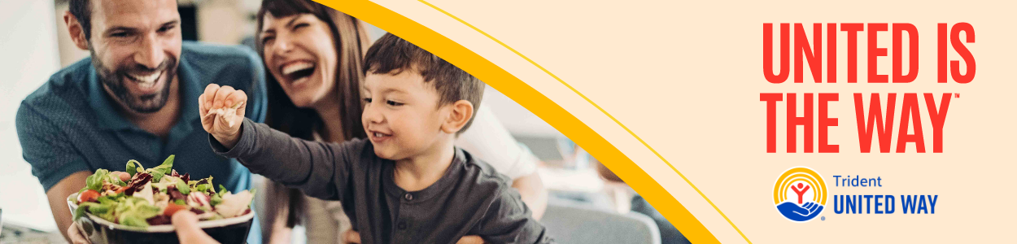
Subject: Celebrate what the [COMPANY] team made possible for families
Dear [Employee’s Name],
We did it! Thanks to your generosity during our Trident United Way Workplace Giving Campaign, together we raised $X with [X%] of the team contributing.
Your support means more hardworking families get paired with Family Coaches, tools and resources to overcome impossible choices in their everyday life.
Thank you for coming together and powering what is possible through Trident United Way’s Strong Families, Strong Community Initiative.
With Gratitude,
[Your Name]
[Your Title]
[Company Name]

