Pre-Kickoff Email - Workplace Donor Engagement

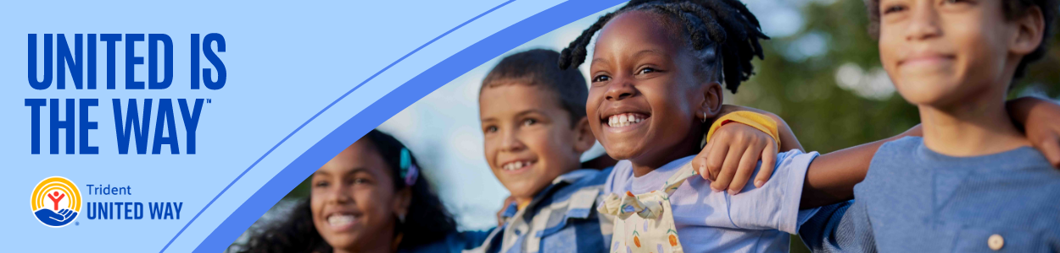
Subject line: Join Us: Building Strong Families + a Strong Community

Dear [EMPLOYEE NAME],

Across the Tri-County, nearly 4 in 10 households are working hard but still struggling to afford the cost of basics. These are families who are contributing to our community every day, yet often just one unexpected expense away from crisis.

That’s why [COMPANY NAME] is proud to support Trident United Way’s Strong Families, Strong Community Initiative, a bold effort to uplift 15,000 families out of poverty by 2035.

When you give, you:
- Provide personalized support through a network of Family Coaches
- Connect ALICE ® families to better jobs, career paths and financial tools
- Meet families where they are: at home, in schools and across our community

Your contribution stays right here in the Tri-County, empowering our neighbors to build stronger futures for themselves and their children.

Thank you to everyone who gave last year, and if you’re new to [COMPANY NAME], thank you for considering a gift. Every dollar makes a difference.

Button Text: LEARN MORE [insert campaign, company specific link]
[Your Name]
[Your Title]
[Company Name]

